Patient and Public Engagement Strategy
2019 - 2022

Our Visions and Values

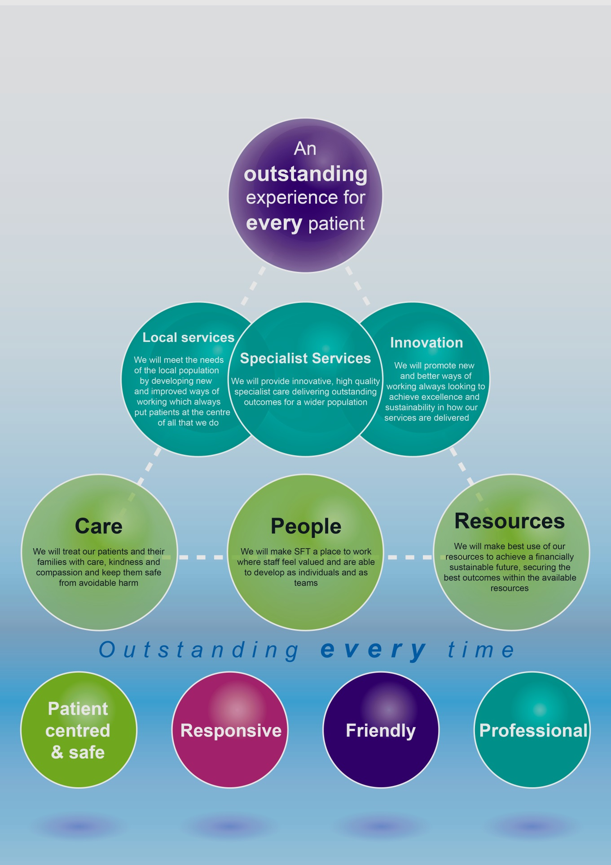

Introduction
Patient experience has been identified as a key element of patient care across the NHS. It enables those who use our services to direct us through feedback, involvement and engagement to provide care that is not only clinically outstanding but provides a holistic approach to our patients’ wellbeing whilst they are in our care.
Patient’s experience of care, clinical effectiveness and patient safety together make the three key components of quality in the NHS. Good care is linked to a positive experience and is also associated with high levels of staff satisfaction
An outstanding experience for every patient is our main priority. Patients are at the heart of our services and we will build on existing good practice to continue to design our services around our patients’ needs.
Review of the previous strategy
The Trust’s 2016-2019 engagement strategy set out 9 priorities to make public and patient engagement a core part of our organisational culture. The aim of the strategy was to build a thorough and accurate understanding of patient experience, through gathering quantitative and qualitative information from patients, their families and carers and use this as a tool for real quality improvement to achieve our priorities.
See Appendix 3 for a glossary of all terms used.
2016/2019 priorities
- Strengthen the PALS Public and Patient Involvement (PPI) role
- Directorate Management Teams to consult with the PALS PPI lead about involving patients in planned service change
- Develop the ward-based patient experience action plans
- Develop ward/departmental patient experience ‘You said – We did’ boards
- Report PPI projects via the patient experience quarterly report and annual report to the Clinical Governance Committee and Trust Board
- Strengthen concerns and complaints responsiveness by working with the directorate management teams
- Engage in the national patient survey programme
- Engage with partners, such as Healthwatch Wiltshire, on patient experience initiatives
- Share the outcomes of projects with staff on the Intranet and develop a resource on the hospital website for the public.
Key successes to date
- In 2017/18 - 2,800 patients were surveyed via the inpatient surveys, 11,440 Friends and Family Test (FFT) cards were returned and 1,475 patients were surveyed via real time feedback, enabling our staff to see and action the feedback
- In 2017/18 - 23 PPI trust-wide initiatives were reviewed and approved by the PPIG group (appendix 2) and were completed
- Patient and staff stories are heard at bimonthly Trust Board meetings. Our method of doing this has been shaped by feedback from patients who told their stories at earlier Clinical Governance Meetings.
- Patient Magnets - symbol magnets introduced to wards to enable easy identification of additional support needs for individual patients
- ArtCare’s engagement work with the local community and patients on a wide range of improvement work
- Certification against NHS England’s Information Standard
- Accessible communication policy ratified
- Information boards outside all inpatient areas provide ward information and contact details
- Customer Care Boards have been sited outside all inpatient areas with details of how to give feedback. Space is available for feedback on actions taken.
- Ward ‘Hot Boards’ have been sited outside all inpatient ward areas.

Patient and Public Engagement Strategy 2019 - 2022
This new three-year is a refresh of the previous strategy - it does not start from a ‘blank sheet’. It reflects the first of our Trust values ‘patient-centred and safe’ and a commitment to continuously strengthen patient and public engagement across the organisation in order to meet our overarching aim of ‘an outstanding experience for every patient’.
Our patient and public experience and involvement priorities 2019 - 2022
These priorities were discussed and agreed with patients, the local Health Watch Manager and Health Watch patient representatives and an NHS England Patient Engagement Fellow.
All consulted were happy with the suggested priorities. Changes were made to simplify the language used and, at their suggestion, a glossary of terms was added. Of note a suggestion was made to invite patients/carers to review patient and public involvement applications for a sense check and to ensure that the questions asked are accessible.
- Communication
We want to build on the work that has already taken place and improve the way we listen to and communicate with our patients their families and their carers
To do this we will:
- Proactively capture the experiences of our patients
- Review experience (positive and negative) and learn from it to continuously improve our services and how people are involved
- Encourage feedback via electronic means
- Publicise where we have made changes as a result of patients’ feedback
- Help staff to translate feedback into local actions
- Improve how patient information is made available electronically
- Continue to engage with the national patient survey programme and take action on feedback given
- Continue with real time feedback surveys undertaken by volunteers and governors
- Communicate the available feedback channels so that patients and visitors know how they can pay a compliment, raise a concern or make a complaint
- Ensure the Patient Experience Boards are kept up-to-date and useful for patients and their visitors
- Review our website to ensure it is accessible, navigation is clear and information given is current. Explore ways to make the website more responsive.
- Explore ways to make the Salisbury District Hospital App more patient-friendly and useful.

- Working together
We want to review patient experience (positive and negative) and learn from it so we can improve our services and how people are involved
To do this we will:
- Reach out and work in partnership with our patients, carers and local communities to improve the way services are delivered
- Continue to involve patients (and their carers) in decisions about their care
- Include patients and carers in Trust groups such as nutrition, dementia and end of life care
- Hold PALS surgeries in our local community so that we can help people navigate through our services and help them if they are having problems when encountering our services
- Review our PPI toolkit, update it and re-launch it with staff
- When staff are developing questionnaires for patient feedback, consider how patients can be involved so that the questions asked are understandable and written in plain English.
- Support staff who want to involve patients and the local community
- Continue to hold our Carers Cafes (for our patients and for our staff)
- Continue to learn from and share learning as a result of deaths of patients in our care.

- Outstanding care
We want our patients, their families and carers to have an outstanding experience first time and every time they come into contact with our staff
To do this we will:
- Review our patient experience training
- Capture, celebrate and publicise positive feedback from patients and staff
- Implement person-centred care initiatives, such as the purple butterfly, ‘This is Me’, #endPJparalysis and John’s Campaign
- Engage with and support carers to give feedback on their experiences of care
- Support carers through the Carers’ Café
- Roll out Making Every Contact Count (MECC) training
- Continue to promote our Freedom to Speak Up initiative for staff to escalate concerns and empower staff to take appropriate actions as required.
- Investigate whether there are any charter marks we should be working towards.

Who is responsible for putting our strategy into action and how will we report our progress
Everyone in the Trust is responsible for supporting patient and public engagement and the activities relating to the implementation of this strategy.
The role of the PALS Team is to programme manage the implementation of the strategy, but it is also responsible for delivering a small number of objectives too, which will require contributions from a range of departments.
To monitor progress of the public and patient engagement strategy, a biannual report will be presented to the Clinical Management Board, Clinical Governance Committee and Trust Board.
This strategy has been designed to be flexible and responsive to patient, carer and public needs. Priorities may change under the overarching priorities if patient, carer and public feedback, regulatory, external directives, or health economy priorities steer the Trust in this direction.

Key drivers of patient experience – the national picture
The NHS Long Term Plan sets out how the NHS will be made fit for the future, and to get the most value for patients out of every pound of taxpayers’ investment
- It calls for a ‘fundamental shift’ in the way that the NHS works alongside patients and individuals. Highlighting the need to create genuine partnerships between professionals and patients, it commits to training staff to be able to have conversations that help people make the decisions that are right for them.
- There is a commitment to increasing support for people to manage their own health, beginning in areas such as diabetes prevention and management.
- The plan also includes a focus on supporting carers. It encourages the national roll-out of carer’s passports, which enable staff to identify someone as a carer and involve them in the patient’s care and promises a more proactive approach to supporting young carers.
The White Paper, ‘Equity and Excellence: Liberating the NHS’ highlights the central aim of putting patients and the public first, to offer greater choice and control. This includes shared decision making, underpinned by the principle ‘nothing about me without me’.
The National Institute for Health and Care Excellence (NICE) Quality Standards for patient experience in adult services sets the foundation for an 'NHS cultural shift' towards a truly patient-centred service; making it clear that we must carry on embedding good practice in all that we do.
A number of other national policy drivers have informed our approach and listed below is a brief description of each driver’s key message:
- High Quality Care for All stresses that the NHS needs to work in partnership to prevent ill health and provide care that is personal, effective and safe
- The NHS Constitution makes it clear that the general public have a right to be involved in the decision about the planning and delivery of local services. This will help the NHS to demonstrate that it is responding to the views and experiences of local people
- NHS Outcomes Framework 2015-16 Domain 4 - ensuring people have a positive experience of care
- Quality Accounts – detail how the quality of each NHS service provider is measured by looking at patient safety, the effectiveness of treatments patients receive, and patient feedback about the care provided.
- The Health and Social Care Act set up the Care Quality Commission (CQC) and made it a requirement for them to look at people’s experiences of care in the NHS
- The Kings Fund found a wide variation in the quality of health information available for patients in the NHS and warned that the information being produced must meet certain standards
- The Accessible Information Standard aims to make sure that people who have a disability, impairment or sensory loss can communicate effectively with health and social care services and are given information that they can easily read or understand
- NICE guideline: Community Engagement improving health and wellbeing and reducing health inequalities – includes good practice principles on engagement and how to make engagement more effective
The Ladder of Engagement recognises that engagement is valuable on every step of the ladder, although participation becomes increasingly more meaningful at the top of the ladder (see appendix 1)

Appendix 1
NHS Engagement Ladder
Core to the Patient and Public Engagement Strategy is a cultural shift from ‘doing to’ to ‘working with’ our patients and local community.
The Engagement Ladder is a model promoted by NHS England which shows the steps that staff can take to make their engagement with patients and members of the public more meaningful.

Appendix 2
Patient and Public Involvement Group
Terms of Reference
Purpose
The purpose of the Patient and Public Involvement Group is to support the Trust moving forward in developing services to meet the needs of patients and the public. It is a forum for health professionals and representatives involved in patient and public involvement in all areas of secondary care, providing peer support and discussion to understand the patient and public experience, ensuring robust standards are met.
Objective
- To provide a forum for regular discussion via email of proposed projects, updates, actions and feedback on developments relating to projects that have been undertaken involving patients and the public.
- To provide facilitator support where necessary.
- To provide support for teams wishing to undertake a project by ensuring that they are compliant with:
  - Data Protection
  - Equality and diversity
  - Confidentiality
  - Document legibility and readability
- To provide expertise with regard to implementation of user involvement being undertaken in all areas of the Trust.
- To support the Trust to move forward in PPI to drive change and to meet the needs of the patients and carers.
Accountability
To report to the Clinical Governance Committee and Trust Board via the quarterly Patient Experience report.
Membership
- Head of Patient Experience (Chair)
- Customer Care Advisor - PPI
- Trust Innovation Lead
- Clinical Audit Facilitator
- Project Manager, PMO
- Head of Therapies
- Matron for Quality Improvement
Frequency and format of email communication
- PPI project applications to be circulated via email, on receipt of the draft proposal, for comment and agreement.
- Applicants to be informed in writing whether their project has been approved or not.
- Face-to-face support for project leads is available from the PPIG members.
Quorum
The quorum for project approval is three members, including at least one of the following:
- Head of Patient Experience
- PPI Lead

Appendix 3
Glossary of terms used:
Term | Explanation
Accessible Information Standard | All organisations providing NHS care and/or publicly-funded adult social care are legally required to follow the Accessible Information Standard. The Standard sets out a specific, consistent approach to identifying, recording, flagging, sharing and meeting the information and communication support needs of patients, service users, carers and parents with a disability, impairment or sensory loss.
Clinical Governance Committee | A hospital committee with representation from executives, non-executive directors and clinicians from all areas within the hospital. It works to provide assurance to the Board that the Trust has a robust framework for the management of key critical clinical systems and processes
Customer Care Boards | Customer Care Boards are displayed in corridors outside all the inpatient areas in the hospital. Patient feedback is highlighted in a ‘you said, we did’ section. The boards are also used as a communication tool (for example when wards are closed due to infection)
Friends and Family Test (FFT) | The Friends and Family Test is a feedback tool that supports the fundamental principle that people who use NHS services should have the opportunity to provide feedback on their experience. Listening to the views of patients and staff helps identify what is working well, what can be improved and how.  The FFT asks people if they would recommend the services they have used and offers a range of responses. When combined with supplementary follow-up questions, the FFT provides a mechanism to highlight both good and poor patient experience. This kind of feedback is vital in transforming NHS services and supporting patient choice.
Make Every Contact Count (MECC) | Making changes such as stopping smoking, improving diet, increasing physical activity, losing weight and reducing alcohol consumption can help people to reduce their risk of poor health significantly. Making every contact count (MECC) is an approach to behaviour change that utilises the millions of day to day interactions that organisations and people have with other people to encourage changes in behaviour that have a positive effect on the health and wellbeing of individuals, communities and populations.
NHS England’s Information Standard | The Information Standard is a quality standard that supports the production of high quality information by organisations having a robust information production process based on best practice to ensure that information it produces meets the needs of its patients.
Patient and Public Involvement  (PPI) | Patient and Public Involvement is the way in which patients, the public and carers can:  - Influence their own care and treatment  - Have a say in the way services are planned and run  - Help bring about improvements to the way care is provided.
Patient and Public Involvement Group  (PPIG) | A hospital-based forum that provides peer support to understand patient and public experience throughout the hospital. Supports trust staff to ensure robust standards are met when involving patients in improvement projects
Patient Advice and Liaison Service  (PALS) | The Patient Advice and Liaison Service (PALS) offers confidential advice, support and information on health-related matters. They provide a point of contact for patients, their families and their carers. A PALS office can be found in all NHS hospitals
Patient Experience Boards | Patient Experience Boards are sited outside each ward across the Trust. They show key quality metrics at a glance and include how feedback from patients has been used to improve the service.
Salisbury NHS Foundation Trust’s App | An app developed initially to facilitate online feedback but developed to include wayfinding and news about the hospital.
PPI toolkit | A ‘how-to guide’ for staff wanting to involve patients in improvement work
Trust Board | The Trust Board is the statutory authority, which sets the overall strategy for the Trust and monitors performance. The Trust has eight non-executive directors, including the Chairman, and six executive directors. Non-executive directors bring an independent view to the decision making process of the Board.

ArtCare projects. Salisbury NHS Foundation Trust. Available at: http://www.artcare.salisbury.nhs.uk/projects.htm
The Information Standard. NHS England. Available at: https://www.england.nhs.uk/tis/
Making Every Contact Count. Health Education England. Available at: https://www.makingeverycontactcount.co.uk/
The NHS Long Term Plan. (January 2019) Available at: https://www.longtermplan.nhs.uk/wp-content/uploads/2019/01/nhs-long-term-plan.pdf
Equity and excellence: liberating the NHS. (July 2010) Department of Health. Available at https://assets.publishing.service.gov.uk/government/uploads/system/uploads/attachment_data/file/213823/dh_117794.pdf
Patient experience in adult NHS Services. Quality Standard [QS 15] (February 2012). National Institute for Health and Clinical Excellence. Available at: https://www.nice.org.uk/guidance/qs15
High Quality Care for All – NHS Next Stage Review Final Report (June 2008). Department of Health. Available at: https://www.gov.uk/government/publications/high-quality-care-for-all-nhs-next-stage-review-final-report
The NHS Constitution – the NHS belongs to us all (July 2015) NHS England. Available at: https://www.gov.uk/government/publications/the-nhs-constitution-for-england
The NHS Outcomes Framework 2015/16 (Dec 2014). Department of Health. Available at: https://www.gov.uk/government/publications/nhs-outcomes-framework-2015-to-2016
About Quality Accounts. Available at: https://www.nhs.uk/using-the-nhs/about-the-nhs/quality-accounts/about-quality-accounts/
The Health and Social Care Act (2008) Available at: https://www.legislation.gov.uk/ukpga/2008/14/contents
Producing quality patient information (November 2016) The Kings Fund. Available at: https://www.kingsfund.org.uk/blog/2016/11/producing-quality-patient-information
The Accessible Information Standard. (2017) NHS England. Available at: https://www.england.nhs.uk/publication/accessible-information-standard-specification/
Community engagement: improving health and wellbeing and reducing health inequalities (March 2016). NICE Guideline 44. Available at https://www.nice.org.uk/guidance/ng44
Ladder of engagement. NHS England. Available at: https://www.england.nhs.uk/participation/resources/ladder-of-engagement-2/

