

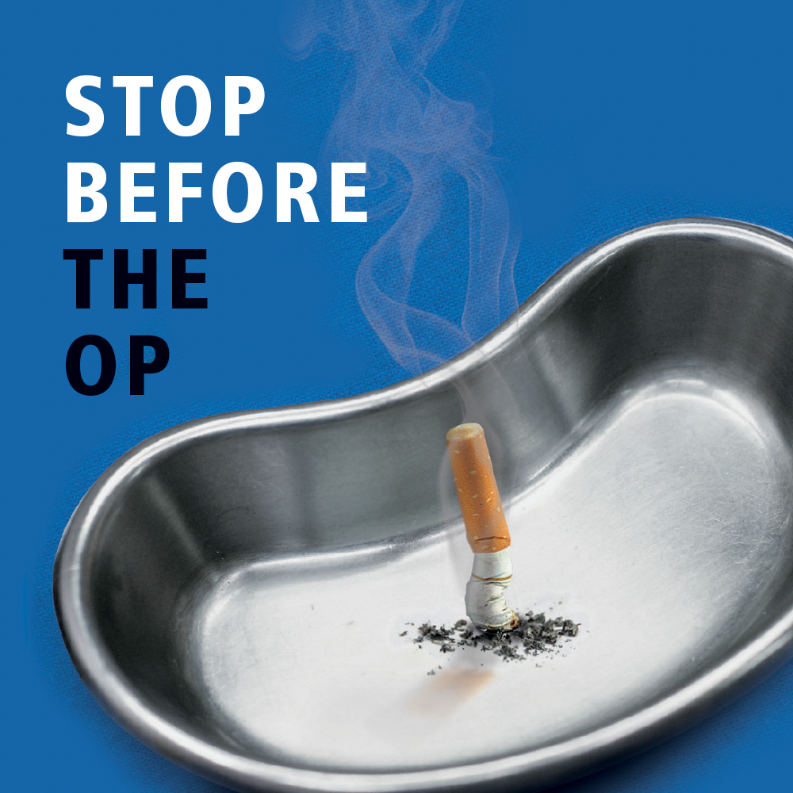

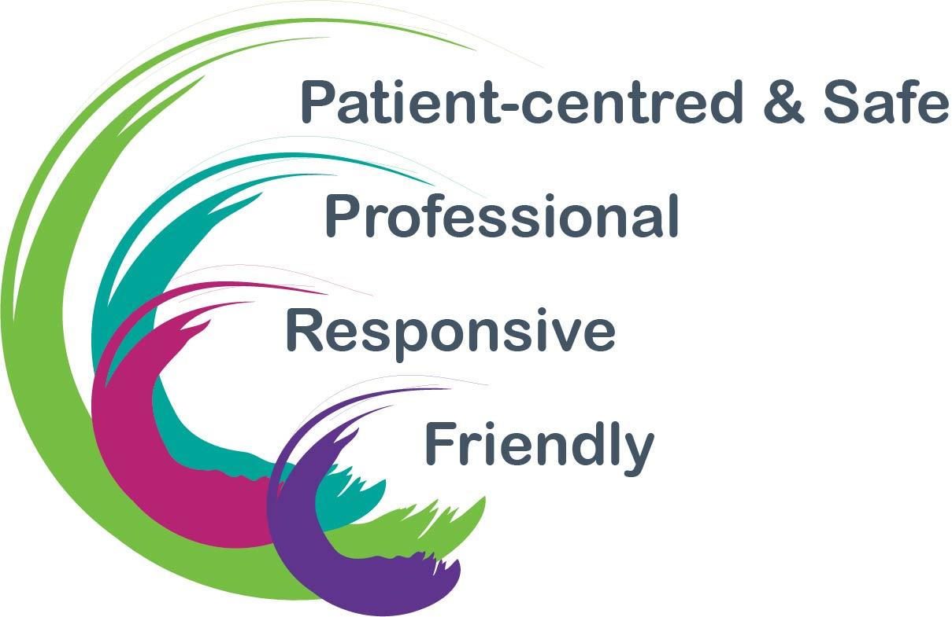

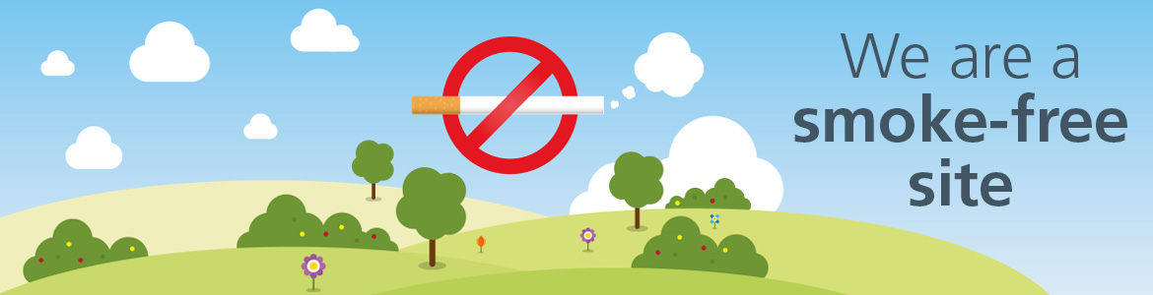

Smoke free site.

Salisbury District Hospital site has been smoke free since January 1st 2019. This means that you are not allowed to smoke anywhere on site including in your own car parked in the hospital car park. Vaping is allowed in the designated shelters. This helps to promote healthy lifestyles and protect everyone from the dangers of second hand smoke.

We know that stopping smoking brings many health benefits and a planned operation can be a perfect opportunity to think about and improve your health.

Benefits of quitting.

Stopping smoking, for as long as possible, before an operation, helps make the procedure safer for you. The benefits of quitting before surgery includes:
- quicker recovery
- shorter admission
- reduced infection risks
- fewer heart and lung complications
- better wound healing
- less anaesthetic
- lesser chance of intensive care support

How smoking harms the body.
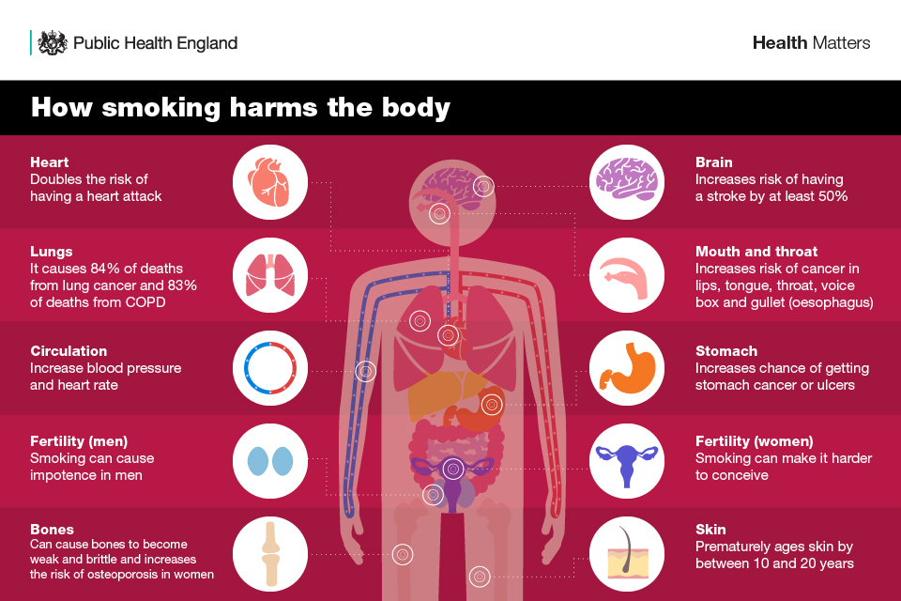

Long term benefits of quitting.
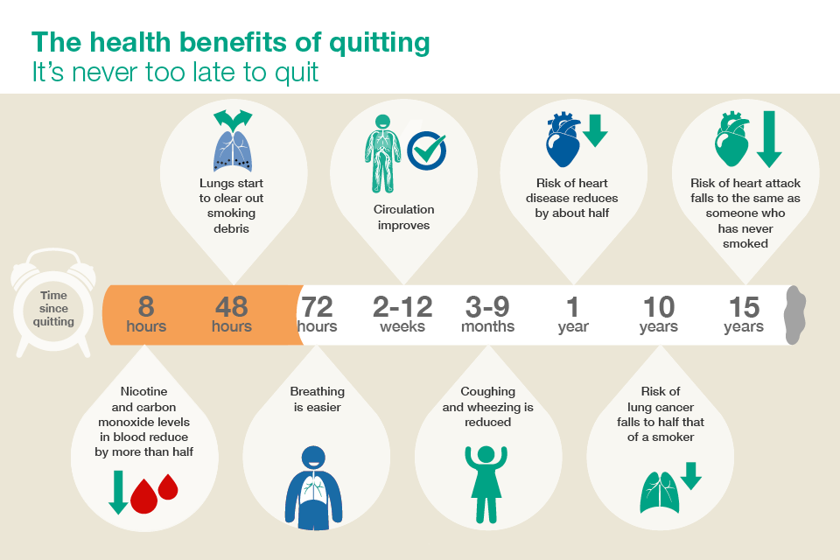

What support is available at Salisbury Hospital?

All patients having surgery will be sent a health questionnaire to complete and return. Smoking history helps staff be aware if you smoke or not.

Things you can do.

- Stop smoking
Stopping smoking before your surgery will improve your health and reduce complications. Staff will happily sign post you to your local stop smoking service in the community. Please just ask.
- Bring in nicotine replacement therapy (NRT)
Remember to bring your own supply of NRT when you come to hospital to help with cravings.
- Keep your mind busy
Distractions from smoking like reading, colouring, puzzles or knitting are examples of how you can occupy your mind. Keeping your mind busy and using NRT products helps with cravings
- Be honest
During your hospital visit, it is likely that staff will ask if you smoke. Please be honest. Staff are gathering the information they need to care for you safely. All staff are happy to help and support you in any way needed.



Ask Ask Ask!

- Ask for NRT
Wards have their own supply of NRT, which can be prescribed for you at any point. You may be asked if you would like this but you can also ask to have some.
- Ask to see the Smoking Cessation Nurse Specialist
There is a part time smoking cessation nurse specialist who supports in-patients. Again, you may be asked if you would like to be referred and you can also ask to be referred.
- Ask about support for when you are discharged
Sometimes patients are discharged without being seen by the smoking cessation nurse specialist so it is important to access support in the community. You are 4 times more likely to be successful with a combination of NRT and specialist support than just NRT alone.

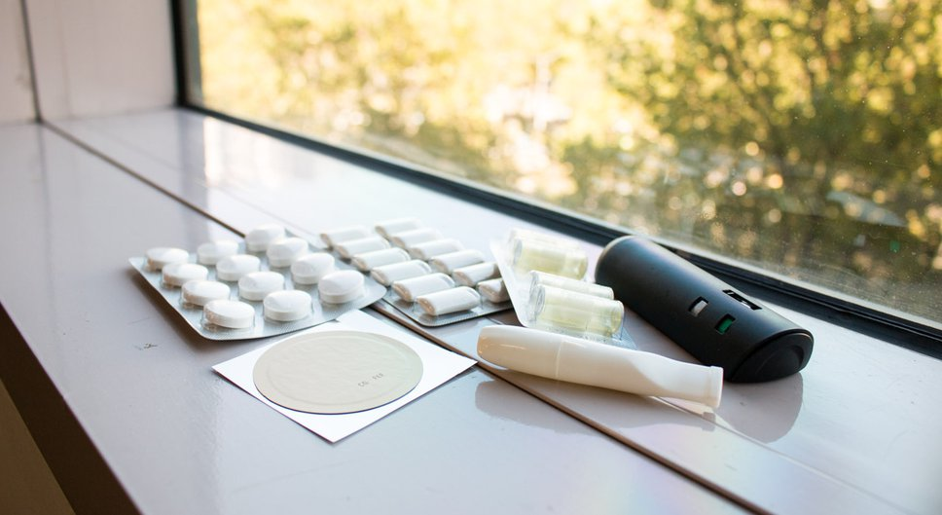

What support is available to help me quit when I leave hospital?

There is a lot of support available to those quitting smoking. It is important to access your local support in the community as they will have information about other aspects of support available in your local area. Much support can be accessed online, using apps, over the telephone and of course face to face meetings. Please see below for the services to access according to which county you live in or indeed the national online help.
Smoking cessation services are available at most GP surgeries and many pharmacies. Visit www.wiltshire.gov.uk/smokefree to find your nearest service
Health trainers provide a free service for many lifestyle changes including smoking cessation.
Tel: 0300 0034566
Email: health.trainers@wiltshire.gov.uk
www.wiltshire.gov.uk/public-health-trainers
Wiltshire patients



Hampshire patients
Register with this free NHS service to access support.
Tel: 01252 335120 Mon-Fri 9am-5pm
Email: quit4life@nhs.net
www.quit4life.nhs.uk
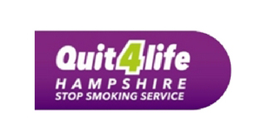
Register to access free information and support for
smoking cessation and other lifestyle changes.
Tel 0800 8401628 or 01305 233105
Email: hello@livewelldorset.co.uk
www.livewelldorset.co.uk
Dorset patients


National support
NHS smokefree app and www.nhs.uk/smokefree
www.nhs.uk/oneyou
NHS Smokefree 0300 123 1044
Mon-Fri 9 am-8pm weekends 11am-4pm
Quitline 0800 00 22 00
Weekdays 9am-8pm except Tues 9am-530pm



Good luck and we look forward to seeing you soon.

