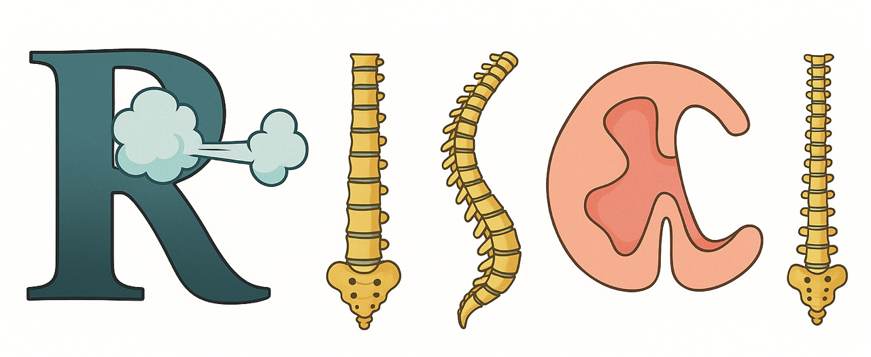

Respiratory Information for Spinal Cord Injury, GBI

A Matter of Life and Breath
Thrive, not just survive, when your breathing is affected by SCI

17th National RISCI Conference, Friday 27th March 2026

Kindly sponsored by: 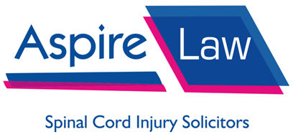

CPD points applied for: Royal College of Physicians

CALL FOR ABSTRACTS

Abstracts (research or clinical cases) are invited for oral or poster presentation at the next
RISCI National Conference

Please complete the form overleaf and return to email: sft.risciconference2026@nhs.net
Submissions by: 31st October 2025
Awards will be made at the end of the day for the best oral presentation judged by the committee, and the best poster as voted by the conference delegates.
A Matter of Life and Breath
Thrive, not just survive, when your breathing is affected by SCI

17th National RISCI Conference, Friday 27th March 2026

Abstract Submission
Name of presenting author:
Title/Clinical role:
Spinal Cord Injury Centre/Trauma Centre/Hospital/Organisation:

Email:
Tel. no:
Abstract title:
Abstract (250 word maximum):

Please indicate preference: Poster Oral

Please do not include any political comments in your presentation or poster or remarks
Please send completed abstracts by 31st October 2025 to sft.risciconference2026@nhs.net with the subject “RISCI abstract”

