Dear

On checking the TIS database I can see your ALM user name is:

You can request an automated email with fresh login details from ALM by clicking on their url [https://accent.hicom.co.uk/Portal/LIVE/Web/](https://gbr01.safelinks.protection.outlook.com/?url=https%3A%2F%2Faccent.hicom.co.uk%2FPortal%2FLIVE%2FWeb%2F&data=05%7C01%7Canna.spicer%40nhs.net%7C515e82809089415bb61d08db97546c7c%7C37c354b285b047f5b22207b48d774ee3%7C0%7C0%7C638270161066215913%7CUnknown%7CTWFpbGZsb3d8eyJWIjoiMC4wLjAwMDAiLCJQIjoiV2luMzIiLCJBTiI6Ik1haWwiLCJXVCI6Mn0%3D%7C3000%7C%7C%7C&sdata=JqkNWiXfOQR3OtWpGCeg7lGkVBG%2BvwAjC04MJOTwDZA%3D&reserved=0)   and then clicking on the Forgotten password? text

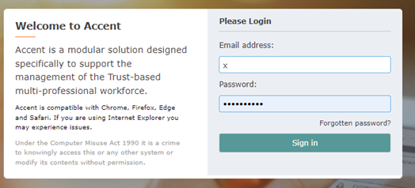

 You should then be taken to this screen where you can input your email address and the fresh password link will be sent to you.

