

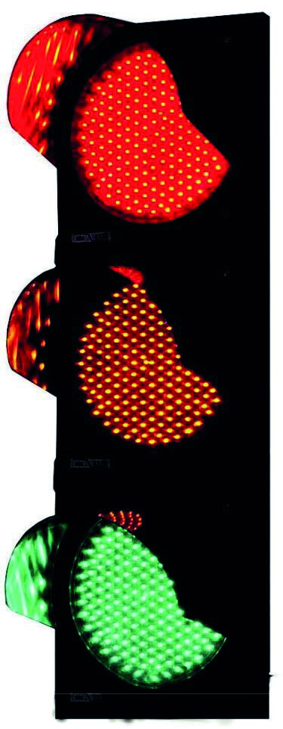
Hospital
Passport
Learning Disability
People with a
for
T
his hospital traffic
light
assessment gives hospital
staff important information
about you
Information the hospital
must know about you
Information the hospital
needs to know about you
Information the hospital
should know about you
Please take your Passport with you if you have to go into Hospital

This passport belongs to me. Please update it and give it back to me when I leave hospital.

See also: (please tick if applicable)
- SaLT Assessment ☐
- Comprehensive Epilepsy profile ☐
- Medication guide ☐
- MARS Sheet ☐
- CTPLD Health Assessment ☐
- Hospital Liaison Pathway ☐

Things you must know about me

 | My Name: |  | My NHS Number
 | I like to be called |  | Date I was born
 | My address: | 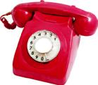 | My Telephone Number:
 | My GP : |  | My GPs telephone Number
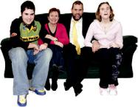 | My next of kin  Relationship to me: |  | My NOK telephone number
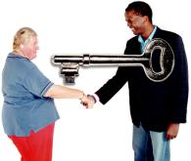 | My Key Worker |  | My Key Worker telephone number
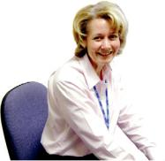 | Other Professionals involved: |  | Professionals telephone number
 | My religion: |  | Things that I am allergic to:
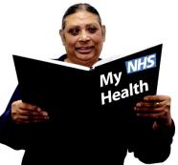 | My health problem and brief medical history:
 | My level of understanding and capacity to consent
 | Behaviour of concern that may cause a risk eg risk of leaving without support:

Things you need to know about me

Information sharing – how can you help me to understand things:

How I communicate:

Any problems that I have in seeing and hearing

Any problems with eating and swallowing, any help I need

Any problems with drinking and swallowing?

Any problems with going to the toilet or continence aids I use?

How I get about?

What you should do to help me if I get anxious

How can you tell that I am in pain?

How I like to sleep?

Any help I need with personal care?

Level of support – who needs to stay with me and how often

Things you should know about me

Things I like | Things I do not like

 | Medication that I take and how I take it:
Medication | Dose | Reason I take it

